Assignment 13

Using the UNION clause.

Question 1 = Create a union of two queries that shows the names,cities, and ratings of all customers. Those with a rating of 200or greater will also have the words “High Rating”, while the others will have the words “Low Rating”.

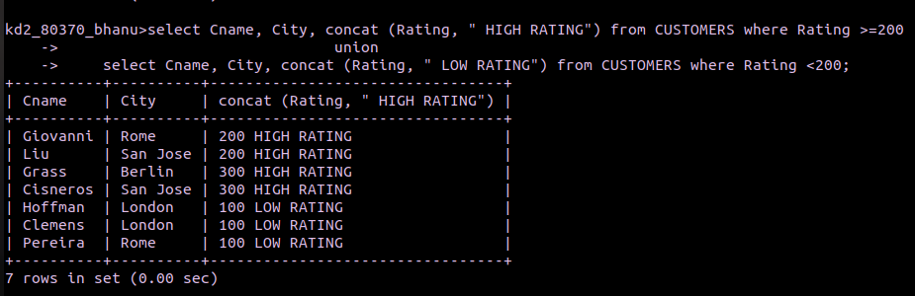
Question 2 = Write a command that produces the name and number of each salesperson and each customer with more than one current order. Put the result in alphabetical order.
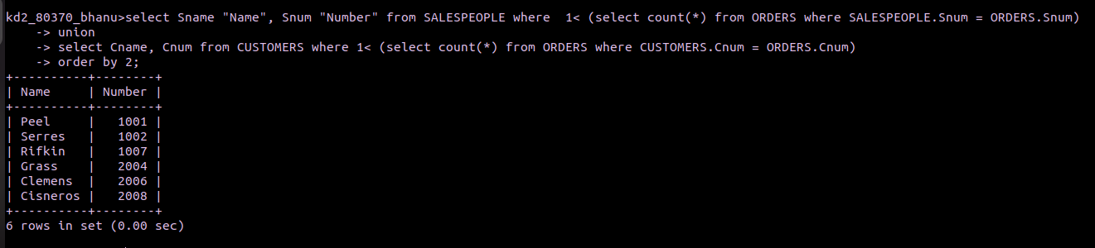

Question 3. Form a union of three queries. Have the first select the snums of all salespeople in San Jose; the second, the cnums of all customers in San Jose; and the third the onums of all orders on October 3. Retain duplicates between the last two queries but eliminate any retundancies between either of them and the first.

